**Bitplane Slicing**

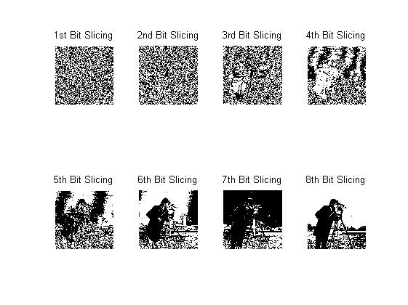



* We get bits of 8-bit, 256 grey shade colours and plot them in the figure above.
* Observed that most meaningful or representative information is present in 8th bit. 7th and 6th bit also contain information about the image more than 1-5th bit.
* 1st to 3rd bits just contain some random noise information.

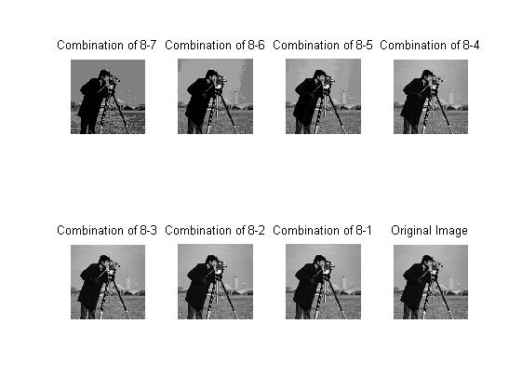



* In the above experiment, we combined the bit information from 8th bit with other bits. Combination of 8-x denotes combining all bits from 8 to x.
* We observed combining 8th to 4th bits together form the image very close to original image. So, even if we loss the information from 1st to 3rd bit, the image resembles closely to original image.
* Also, the image intensity values after combining 8th to 1st bit is same as that of original image.